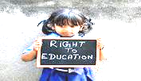
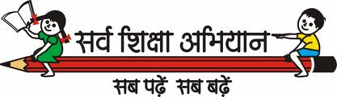
Paper – 2012 SA 2
Class – 10th
Subjects – Mathematics (Areas related to circles and surface area and volumes)
General Instructions:
- All questions are compulsory.
2 marks type Questions. AND 3 marks type Questions.
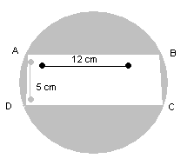
Q1. In figure 1, find the area of the shaded region. (Use =3.14) {ans. 72.665 cm^{2}}
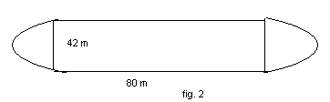

Q2. A playground in the form of a rectangle having semicircles on the shorter sides as shown in fig. 2. Find its area when the length of the rectangular portion is 80 m and the breadth is 42 m. {Ans. 4746 cm² )
Q3. A toy is in the form of a cone mounted on a hemisphere of common base radius 7cm. the total height of the toy is 31 cm. find the total surface area of the toy. {ANS 858 cm^{2}}
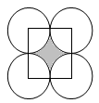
Q4. Four equal circles are described about four corners of a square so that each touches two of the others, as shown in fig. Find the area of the shaded region, each side of the square measuring 14cm. (take use =) {Ans. 42 Sq. cm}

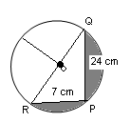
Q5. In figure PQ=24cm, PR = 7cm and o is the centre of the circle. Find the area of shaded region (take use =3.14)
{Ans. 161.31 cm² }

Q6. 2 cubes each of volume 64cm³ are joined end to end. Find the surface area of the resulting cuboid.
Q7. The length of the minute hand of a clock is 14cm. find the area swept by the minute hand in 5 minutes. (Use =) {ANS= 51.3 cm²}.

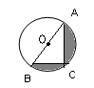
Q8. Find the area of the shaded region in fig. if AC= 24cm, BC = 10cm and o is the centre of the circle. Use = [ANS. 145.53 cm²}

Q.9. In figure, find the area of the shaded region, if ABCD is rectangle with AB =80 cm and BC = 70 cm . Angle AED =90⁰ and DE = 42 cm and a semicircle is drawn with BC as a diameter. Take π= {ANS= 2499cm²}
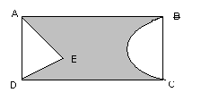

Q10. The radius of the base and the height of a solid right circular cylinder are in the ratio2:3 and its volume are 1617. Cm³. find the total surface area of the cylinder. {Use π=}
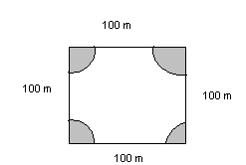
Q11. A square park has each side of 100m. At each corner of the park, there is a flower-bed in the form of a quadrant of radius 14cm as shown in fig.4.
Find the area of the remaining part of the park. {Use π=}. (Ans. 9384 Sq. m.)

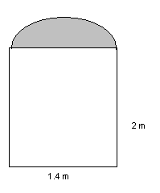
Q12. A room is 8m long, 4.5 m wide high. It has one door 1.4 m wide and 2m high with a semicircular ventilator as shown in fig. and two rectangular windows 2m by 1.5m each. Find the cost of white-washing the inner four walls of the room rate of rs.10per sq. m. . {Use π=}. (Ans Rs.604.30)

Q13. A cylinder of radius 12 cm contains water to depth of 20cm. a spherical iron ball is dropped into the cylinder and thus the level of water is raised by 6.75 cm. find the radius of the ball. . {Use π=}. (Ans. 4)
Q14. The short and long hands of a clock are 4cm and 6cm long respectively. Find the sum of the distances travelled by their tips in two days. . {Use π=}. (Ans 1910.86 cm )
Q15. A hemispherical bowl of internal diameter 36cm is full of some liquid. This liquid is to be filled in cylindrical bottles of radius 3cm and height 6cm. find the number of bottles needed to empty the bowl.
(ans. 72)
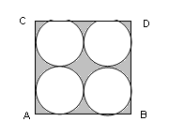
Q16. Find the area of the shaded region in fig. where ABCD is a square of side 14cm. (Ans. 42)

Q17. The area of an equilateral triangle is 49route3 cm². Taking each angular point as centre, circles are drawn with radius equal to half the length of the side of the triangle. Find the area of triangle not included in the circle. {Use π=}.

4 marks type Questions.

Q1. A bucket is made up of metal sheet is in the form of a frustum of a cone, its depth is 24cm and the diameters of the top and bottom are 30cm and 10cm respectively . Find the cost of milk which can completely fill the bucket at the rate of Rs.20 per liter and the cost of the metal sheet used, if it cost Rs.10 per 100cm². {Use π=}. (Ans. Rs.163.28)

Q.2. A sphere of diameter 12 cm is dropped in a right circular cylinder vessel partly filled with water. If the sphere is completely submerged in water, the water level in the cylindrical vessel rises by 32/9cm. find the diameter of the cylindrical vessel. (Ans. 10 cm)

Q.3. A tent consists of a frustum of a cone, surmounted by a cone. If the diameters of the upper and lower circular ends of the frustum be 14m and 26m respectively , the height of the frustum be 8m and the slant height of the surmounted conical portion be 12 m, find the area of canvas required to make tent . (Assume that the radii of the upper circular end of the frustum and the base of surmounted conical portion are equal). (Ans. 89.257 approx.)

Q.4. From a solid cylinder whose height is 8cm and radius 6 cm, a conical cavity of height 8cm and of base radius 6cm, hollowed out. Find the volume of the remaining solid correct to two places of decimal. Also find the total surface area of the remaining solid. (Use =3.1416) (Ans. 603.19 cm³ )

Q.5. A juice seller serves his customers using a glass as shown in fig. the inner diameter of the cylindrical glass is 5cm, but the bottom of the glass has a hemispherical portion raised which reduces the capacity of the glass. If the height of the glass is 10cm, find the apparent capacity of the glass and its actual capacity. (Use =3.14) (Ans. 163.54 cm³ )

Q.6. A milk container is made of metal sheet in the shape of frustum of a cone whose volume is 73216/7cm³. The radii of its lower and upper circular ends are 8cm and 20cm respectively. Find the cost of metal sheet used in making the container at the rate of Rs.1.40 per square centimeter. {Use π=}. (Ans. Rs. 2745.60)

Q.7. a hemispherical depression is cut out from one face of a cubical wooden block of edge 21 cm, such that the diameter of the hemispherical is equal to the edge of the cube. Determine the volume and total surface area of the remaining block. (Ans. 4032 cm² )

Q.8. Find the area of the shaded region in fig where arcs drawn with centre’s A, B,C and D interest in pairs at mid-points P, Q ,R
And S of the sides AB, BC, CD, DA respectively of a square ABCD, where the length of each side of square is 14cm
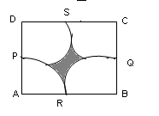
{Use π=}. (Ans. 42 cm².)

Q.9. A toy is in the shape of a solid cylinder surmounted by a conical top. If the height and diameter of the cylindrical part are 21cm and 40cm respectively, and the height of cone is 15cm, then find the total surface area of the toy.
(Use =3.14) (Ans. 63.6 cm²

Q.10. The length and breadth of rectangular piece of paper are 28cm and 14cm respectively. A semi-circular portion is cut off from the breadth‘s side and a semi-circular portion is added on length’s side as shown fig. find the area of the shaded region.
{Use π=}. (623 cm² )

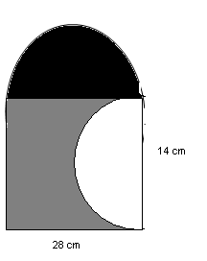

‘kllklkkkkkkkk
LALIT’S TUITIONS CLASSES 6TH TO 12TH CONTACT US: 9716881331 E-mail- powergroup87@gmail.com

