Sample Paper – 2010
Class – X
Subject – SCIENCE

SECTION-A
- Why does an aqueous solution of acid conduct electricity?
- What type of reaction is the one that follows: CaCO₃ (s)CaO (s) + CO₂ (g)
- Give structural formulae of the simplest (i) alkene, and (ii) alkyne.
- What is variable resistance? Which device is used to change resistance in a circuit?
- What is the magnitude of the induced current in the circular loop PQRS of radius r as shown in figure below, if the straight wire AB causes a current of magnitude I ampere?
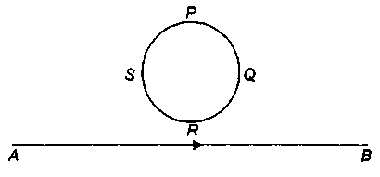

- Which of the following lenses would you prefer to use while reading small letters found in a dictionary?
- A convex lens of focal length 50 cm
- A concave lens of focal length 50 cm
- A convex lens of focal length 5 cm
- A concave lens of focal length 5 cm
- On the basis of the atomic structure, how the first and the last element of a period in the periodic table is determined?
- (i) Distinguish between: (Give chemical reactions)
- Esterification and Saponification.
- Oxidation and Combustion.
(ii) Give an industrial application of addition reaction.
9. Two wires A and B of the same metal have the same area of cross-section and have their lengths in the ratio 2:1. What will be the ratio of currents flowing through them when same potential difference is applied across length of each of the wire?
10. An object is placed at a distance of 25 cm from a spherical mirror and its image is formed behind the mirror at a distance of 5 cm. Find the focal length of the mirror. Is the mirror concave or convex in nature? Give one use of identified mirror.
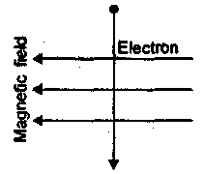
- Watching the sunset on a beach, one can see the sun for two minutes after it has actually set, explain.
- (a) A 16 Q resistance wire is doubled on it. Calculate the new resistance of the wire.
(b) An electron enters a magnetic field at right angles to it as shown in the figure alongside. Determine the direction of force acting on the electron whether on the page or out of the page.
13. Convert the following statement into balanced chemical equations.
- Hydrogen gas combines with nitrogen to form ammonia.
- Hydrogen sulphide gas burns in air to give water and sulphur dioxide.
- Potassium metal reacts with water to give potassium hydroxide and hydrogen gas.
14. (a) What are ionic compounds? How are they formed?
- Show using electron dot structural formula, the formation of compound—MgCl₂.
- Will it be soluble in water? Support your answer with reason.
15. The electronic configuration of an atom X is (2, 8, 7). It combines with another atom Y having one electron in the

outermost shell. (a) What type of bond will be formed between X and Y? (b) Write the formula of the compound formed. (c) Is it soluble in water? Why?
Or
- Define saturated hydrocarbons. What is the other name given to it?
- Name the simplest saturated hydrocarbon.
- Name some organic compounds with different functional groups containing oxygen. Show how they have been derived from the simplest saturated hydrocarbon. Also mention the specific functional group present.
16. (a) State second law of refraction of light.
(b) Draw a diagram showing refraction of light through a rectangular glass slab. What is lateral displacement? How does it depend on thickness of glass slab and angle of incidence?
Or
- A number of bulbs are to be connected to a single source. Will they provide more illumination if connected in parallel or in series?
- (i) What is an electrical fuse? Give the principle on which it works? (ii) What is meant by rating of a fuse? (iii) Why should a fuse of proper rating be used?
SECTION B
- Solar energy is the indirect source of wind energy and hydro energy. Explain how?
- A potted plant is kept in a black coloured cardboard with a hole on one side. Which type of growth will it show? Name the hormone responsible for it.
- Maximum energy is found at which trophic level? What is the status of energy at tertiary consumer level?
- Define biodiversity. Why is it important to conserve biodiversity?
- What role do enzymes play in nutrition?
- In which form are the metabolic wastes generated in the human body? How does the body get rid of them?
- What is a trait? Who contributes to the traits present in a child? How many copies of traits are present in every individual? What is the manner in which a trait is inherited and expressed in an organism?
- What are the ill effects of hormonal pills and copper T?
- List the advantages of vegetative reproduction?
- Why sun is called the ultimate source of energy?
- Enlist all the functions of the blood and also give its composition:
Or
Complete the schematic representation of the breakdown of glucose by different pathways: Also answer the following questions:
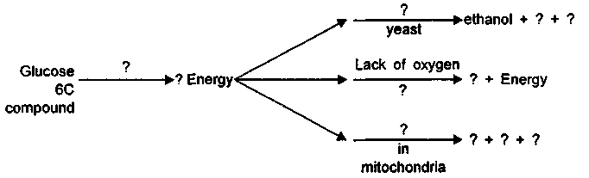
- Why do muscles feel tired and develop cramps?
- Which energy rich compound is produced in respiration?
- Why is less energy produced in anaerobic respiration and more in aerobic
respiration?

Paper Submitted By : Basant Tripathy
Email : basant.physics@gmail.com
Ph No. : 9777702608

